Numpy Hacker Rank
1. Transpose
We can generate the transposition of an array using the tool numpy.transpose.
It will not affect the original array, but it will create a new array.
import numpy

my_array = numpy.array([[1,2,3],
[4,5,6]])
print numpy.transpose(my_array)

#Output
[[1 4]
[2 5]
[3 6]]
Flatten
The tool flatten creates a copy of the input array flattened to one dimension.
import numpy

my_array = numpy.array([[1,2,3],
[4,5,6]])
print my_array.flatten()

#Output
[1 2 3 4 5 6]

Task
You are given a X integer array matrix with space separated elements ( = rows and = columns).
Your task is to print the transpose and flatten results.
Input Format
The first line contains the space separated values of and .
The next lines contains the space separated elements of columns.
Output Format
First, print the transpose array and then print the flatten.
Sample Input
2 2
1 2
3 4
Sample Output
[[1 3]
[2 4]]
[1 2 3 4]
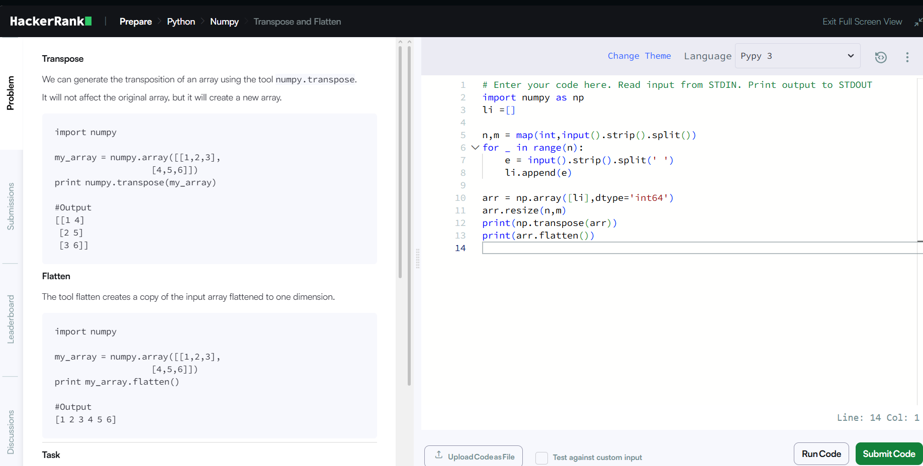

2. Concatenate
Two or more arrays can be concatenated together using the concatenate function with a tuple of the arrays to be joined:
import numpy

array_1 = numpy.array([1,2,3])
array_2 = numpy.array([4,5,6])
array_3 = numpy.array([7,8,9])

print numpy.concatenate((array_1, array_2, array_3))

#Output
[1 2 3 4 5 6 7 8 9]
If an array has more than one dimension, it is possible to specify the axis along which multiple arrays are concatenated. By default, it is along the first dimension.
import numpy

array_1 = numpy.array([[1,2,3],[0,0,0]])
array_2 = numpy.array([[0,0,0],[7,8,9]])

print numpy.concatenate((array_1, array_2), axis = 1)

#Output
[[1 2 3 0 0 0]
[0 0 0 7 8 9]]

Task
You are given two integer arrays of size X and X ( & are rows, and is the column). Your task is to concatenate the arrays along axis .
Input Format
The first line contains space separated integers , and .
The next lines contains the space separated elements of the columns.
After that, the next lines contains the space separated elements of the columns.
Output Format
Print the concatenated array of size X.
Sample Input
4 3 2
1 2
1 2
1 2
1 2
3 4
3 4
3 4
Sample Output
[[1 2]
[1 2]
[1 2]
[1 2]
[3 4]
[3 4]
[3 4]]
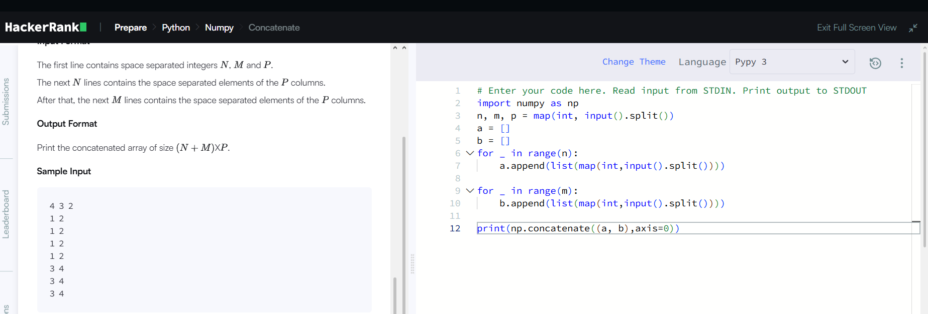
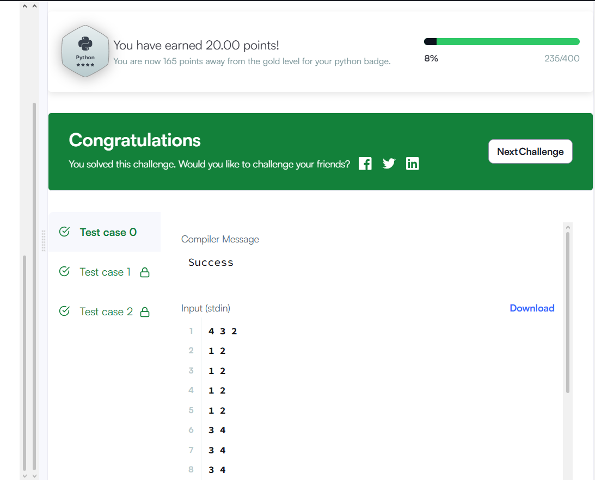
3. zeros
The zeros tool returns a new array with a given shape and type filled with 's.
import numpy

print numpy.zeros((1,2)) #Default type is float
#Output : [[ 0. 0.]]

print numpy.zeros((1,2), dtype = numpy.int) #Type changes to int
#Output : [[0 0]]
ones
The ones tool returns a new array with a given shape and type filled with 's.
import numpy

print numpy.ones((1,2)) #Default type is float
#Output : [[ 1. 1.]]

print numpy.ones((1,2), dtype = numpy.int) #Type changes to int
#Output : [[1 1]]

Task
You are given the shape of the array in the form of space-separated integers, each integer representing the size of different dimensions, your task is to print an array of the given shape and integer type using the tools numpy.zeros and numpy.ones.
Input Format
A single line containing the space-separated integers.
Constraints
Output Format
First, print the array using the numpy.zeros tool and then print the array with the numpy.ones tool.
Sample Input 0
3 3 3
Sample Output 0
[[[0 0 0]
[0 0 0]
[0 0 0]]

[[0 0 0]
[0 0 0]
[0 0 0]]

[[0 0 0]
[0 0 0]
[0 0 0]]]
[[[1 1 1]
[1 1 1]
[1 1 1]]

[[1 1 1]
[1 1 1]
[1 1 1]]

[[1 1 1]
[1 1 1]
[1 1 1]]]
